
Student Number
Mark / 100

2008

TRIAL HSC EXAMINATION

Chemistry

General Instructions

•Reading time – 5 minutes
•Working time – 3 hours
•Write using black or blue pen
• Draw diagrams using pencil
•Write your Student Number at the top of this page and on pages 7,9,11,13,15,17 and 19.
•Board-approved calculators may be used
•A data sheet and a Periodic Table are provided at
the back of this paper. This may be removed for your
convenience.

Total Marks – 100

Section I Pages 3-19

75 marks

This section has two parts, Part A and Part B

Part A – 15 marks
•Attempt Questions 1-15
•Allow about 30 minutes for this part

Part B – 60 marks
•Attempt Questions 16-28
•Allow about 1 hour and 45 minutes for this
part

Section II Pages 20 – 21

25 marks

•Attempt Question 29
•Allow about 45 minutes for this section
Confidential
Keep Secure

Section I
75 marks

Part A – 15 marks
Attempt Questions 1-15
Allow about 30 minutes for this part

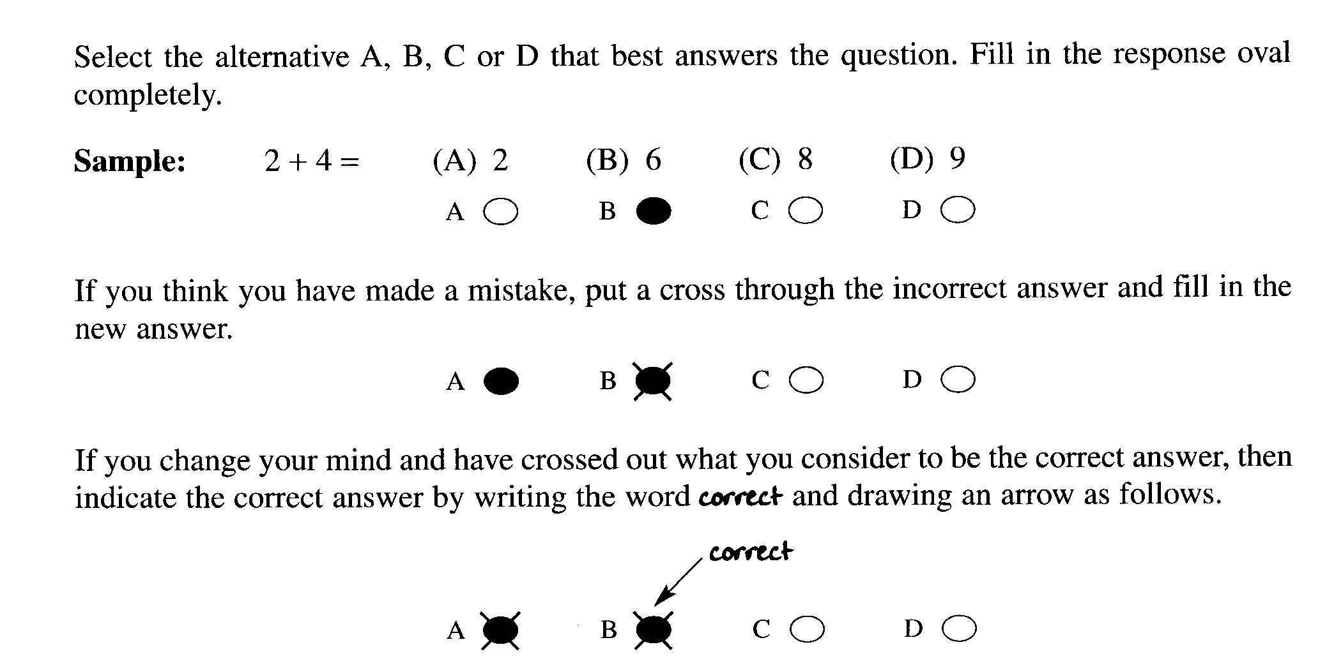

Mark your answers on the ANSWER sheet on page 7.
________________________________________________________________________________
1. Which is the most common catalyst for the manufacture of ethanol from ethene and water?
(A) Yeast
(B) Iron
(C) Hydrochloric acid
(D) Sulfuric acid

The information below relates to questions 2 and 3.

Students measured the mass change in a flask containing glucose solution and yeast. The initial mass
of the flask and contents was 428.1 g and the mass of the flask and contents after a week was 390.1 g.

2. What volume of gas was released at 25ºC and 100 kPa.?

(A) 0.86 L
(B) 19.61 L
(C) 21.40L
(D) 38.0 L

3. What method could be used to separate the other product from the reaction mixture?

(A) Refluxing
(B) Fractional distillation
(C) The use of a separating funnel
(D) Filtration.

4. The heat of combustion of 1-butanol is 36,100 J g^{-1.}.
What is the value of the heat of combustion in kJ mol⁻¹ ?

(A) 488
(B) 1661
(C) 2022
(D) 2676

5. The results of tests involving metals L,M,N,P and solutions of their ions were as follows:

Ions | Metals
 | L | M | N | P
L²⁺ | N/R | Solid deposit | Solid deposit | Solid Deposit
M²⁺ | N/R | N/R | Solid Deposit | Solid Deposit
N²⁺ | N/R | N/R | N/R | Solid Deposit
P²⁺ | N/R | N/R | N/R | N/R

N/R= no reaction

Which metal is the most active?

(A) L
(B) M
(C) N
(D) P

6. Which acid is considered a general component of acid rain?

- Acetic acid
- Nitric acid
- Phosphoric acid
- Sodium hydroxide

7. Bromine gas may be formed from the decomposition of bromine pentafluoride as shown in the equation.

2BrF₅(g) ⇌ Br₂(g) + 5F₂(g) ∆H = 858 kJ mol⁻¹

What will happen to the concentration of bromine if the pressure is increased (temperature kept constant) after the reaction has attained equilibrium?

(A) remain the same because only the reaction rate will change
(B) decrease because there are fewer gaseous reactant molecules than products
(C) increase since the reaction acquires energy from the pressure
(D) decrease because there are more gaseous reactant molecules than products

8. Common oxides include CaO, CO₂, Na₂O and SO₂. Which of these oxides would give a
solution with a pH less than 7, and which oxides would give a solution with a pH greater
than 7?

 | pH <7 | pH >7
(A) | CO₂, SO₂ | Na₂O, CaO
(B) | SO₂, CaO | CO₂, Na₂O
(C) | Na₂O, CaO | CO₂, SO₂
(D) | CO₂, Na₂O | CaO, SO₂

9. The condensed structural formula of an ester that gives a rum-smell is provided.

CH₃CH₂CH₂COOCH₂CH₂CH₃

What two organic compounds would be used to form the rum-smelling ester?

(A) 1-propanol and butanoic acid
(B) 1-butanol and ethanoic acid
(C) propanol and pentanoic acid
(D) 1-butanol and propanoic acid

10. Which organic compound would have the highest boiling point?

(A) hexanoic acid
(B) 1-hexanol
(C) hexane
(D) hexene

11. Which of the following cannot be a Brönsted – Lowry acid?

(A) HCO₃ ⁻
(B) CO₂
(C) H₂CO₃
(D) H₂O

12. What is the common name of 2 – hydroxypropane – 1,2,3 – tricarboxylic acid?

(A) citric acid
(B) hydrochloric acid
(C) acetic acid
(D) propanoic acid

13. The water supply is often treated with the following substances:

(i) chlorine
(ii) fluorine,
(iii) iron (III) chloride
(iv) sodium fluoride.

Which of the substances is/are added to sanitize the water supply?

(A) all of the additives
(B) (i) only
(C) (i) and (ii) only
(D) (i) and (iii) only

14. Which of the following ozones is vital to the survival of all living things on Earth?

(A) atmospheric ozone
(B) stratospheric ozone
(C) tropospheric ozone
(D) mesospheric ozone

15. The colourless aqueous solution of a white solid sample formed a precipitate with
an acidified aqueous solution of lead (II) nitrate. What is the possible identity of the original
solution of this sample?

(A) copper (II) sulfate
(B) barium chloride
(C) sodium sulfate
(D) silver chloride

Student Number …………………………

Section I Mark -----/15

Part A
Multiple Choice ANSWER sheet

1. A  B  C  D 

2. A  B  C  D 

3. A  B  C  D 

4. A  B  C  D 

5. A  B  C  D 

6. A  B  C  D 

7. A  B  C  D 

8. A  B  C  D 

9. A  B  C  D 

10. A  B  C  D 

11. A  B  C  D 

12. A  B  C  D 

13 A  B  C  D 

14. A  B  C  D 

15. A  B  C  D 

Part B. 60 marks
Attempt questions 16 to 28
Allow about 1 hour and 45 minutes for this part
Show all relevant working in questions involving calculations
MARKS
Question 16 (8 marks)

Draw a diagram to show the construction of a galvanic cell that could measure the difference in
potential between silver and zinc.

On the diagram label:
- the anode
- the cathode
- nature of the electrolyte solutions
- the direction and location of electron flow
- the direction and location of positive ion flow

Below the diagram :
- Write half equations and a balanced net ionic equation for the reaction.
- Calculate the potential Eº using the table of standard potentials

Student Number …………………………

MARKS
Question 17 (3 marks)

The condensed structural formula of a monomer is shown.

CH₂ = CHCl

(a) Identify the systematic name of this monomer. 1

…………………………………………………………………………………………

(b) Draw the structure of the polymer made from this monomer (showing 4 monomer units). 1

(c) What is the molecular weight of this polymer made from 4 monomers.? 1

…………………………………………………………………………………………..

MARKS

Question 18 (5 marks)

(a) The value for the heat of combustion of 1-propanol is 2021 kJ mol⁻¹.Calculate the theoretical
volume of water that could be heated from 31ºC to 55ºC if 5g of 1-propanol was used. 2

………………………………………………………………………………………………...

………………………………………………………………………………………………...

………………………………………………………………………………………………...

...................................................................................................................................................

...................................................................................................................................................

(b) If 1-pentanol was used instead of 1-propanol would you expect that a greater or lesser
quantity of fuel could be used to heat the same volume of water by the same amount?
Explain your answer. 3

………………………………………………………………………………………………..

………………………………………………………………………………………………..

………………………………………………………………………………………………..

………………………………………………………………………………………………..

………………………………………………………………………………………………...

………………………………………………………………………………………………...
Student Number …………………………

MARKS
Question 19 (4 marks)

(a) What is a transuranic element? 1

………………………………………………………………………………………………

………………………………………………………………………………………………

(b) Give one example of a transuranic element and describe where and how it is produced. 3

………………………………………………………………………………………………

………………………………………………………………………………………………

………………………………………………………………………………………………

………………………………………………………………………………………………

Question 20 (4 marks)

One hazardous compound is sulfur dioxide.

(a) State one industrial source of sulfur dioxide. 1

................................................................................................................................................

(b) Write a balanced formulae equation to describe how sulfur dioxide may be formed 1

.................................................................................................................................................

(c) Give two reasons why sulfur dioxide may be considered a pollutant. 2

...................................................................................................................................................

....................................................................................................................................................

MARKS
Question 21 (5 marks)

The graph shows the national trends in emissions of nitrogen oxides, volatile organic compounds
(VOC), sulfur dioxide and particulate matter (PM) in the United States over an approximately
50-year time frame.

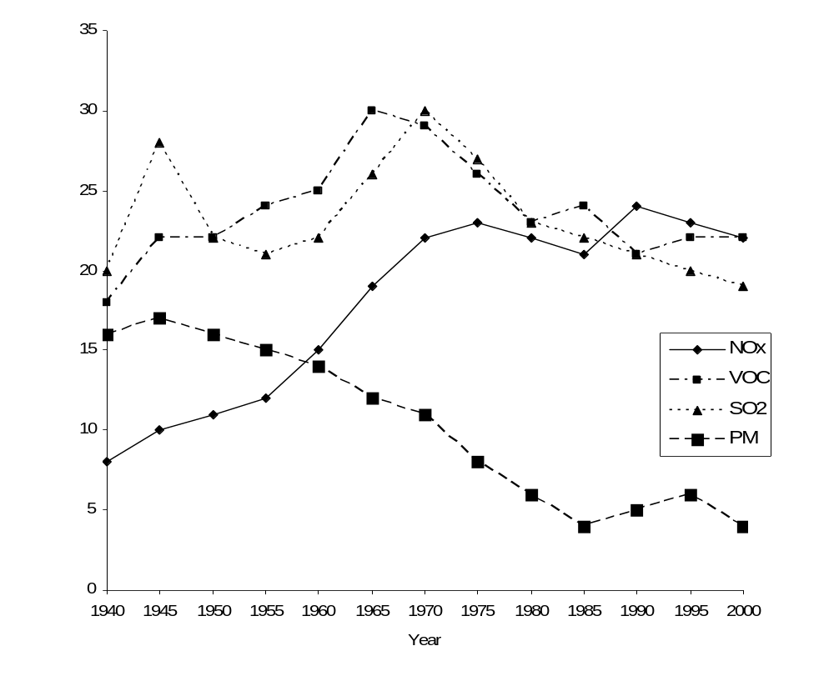

(a) Write the formula for one type of nitrogen oxide. 1

...................................................................................................................................................

(b) Explain the trend observed for the emission of nitrogen oxides over the 50-year period. 2

....................................................................................................................................................

....................................................................................................................................................

.....................................................................................................................................................

.....................................................................................................................................................

Question 21 continues next page...

Student Number …………………………

MARKS
Question 21 continued

(c) Describe how you would assess the validity and reliability of the above evidence for the
emission of nitrogen oxides. 2

..........................................................................................................................................................

..........................................................................................................................................................

..........................................................................................................................................................

..........................................................................................................................................................

Question 22 (5 marks)

When Alka-Seltzer tablets are placed in water, a series of chemical reactions results in the formation
of carbon dioxide and water. The results of an investigation that examined the effects of temperature
on the solubility of carbon dioxide in water are displayed in the table.

 | Beaker 1 | Beaker 2 | Beaker 3 | Beaker 4
Volume of distilled water (mL) | 150 | 150 | 150 | 150
Mass of Alka-Seltzer tablets (g) | - | 2 | 2 | -
Volume of NaOH(aq) added (mL) | 0.5 | 0.5 | 0.5 | 0.5
Temperature of water (ºC) | 6 | 6 | 70 | 70
Amount of Bromothymol blue indicator added (mL) | 2 | 2 | 2 | 2
Colour of solution | light blue | yellow | colourless to light green | light blue

Information regarding the colours of bromothymol blue in acidic, neutral and alkaline solutions is given in the table below.

 | Colour change
Indicator | Highly acidic | Slightly acidic | neutral | Slightly alkaline | Highly alkaline
Bromothymol blue | Yellow | Yellow | Colourless to light green | Blue | blue

Question 22 continues next page....
MARKS
Question 22 continued..

Explain how the results demonstrate the effect of temperature on the solubility of carbon dioxide
in water? 5

..................................................................................................................................................................

..................................................................................................................................................................

..................................................................................................................................................................

.................................................................................................................................................................

..................................................................................................................................................................

..................................................................................................................................................................

..................................................................................................................................................................

..................................................................................................................................................................

..................................................................................................................................................................

..................................................................................................................................................................

Question 23 (4 marks)

A 0.126 mol L⁻¹ solution of a triprotic acid, H₃A, has a pH of 4.56.

(a) Is H₃A a weak or a strong acid? Justify your answer. 1

........................................................................................................................................................

........................................................................................................................................................

(b) Calculate the volume of a 0.432 mol L⁻¹ NaOH which will react completely with
20.0 mL of the acid. Show your working. 3

......................................................................................................................................................

......................................................................................................................................................

......................................................................................................................................................

......................................................................................................................................................
Student Number …………………………
MARKS
Question 24 (3 marks)

Despite extreme care, Anne Koh, a top Chemistry student, spilled some concentrated
sulfuric acid on a school wooden bench. What chemical substance should Anne use to minimise
the damage to the table and lessen the associated hazard of the spilled concentrated acid?
Justify your choice by citing appropriate desirable characteristics of the chemical of your choice.
Include in your answer a balanced chemical equation. 3

......................................................................................................................................................................

......................................................................................................................................................................

......................................................................................................................................................................

......................................................................................................................................................................

......................................................................................................................................................................

Question 25 (2 marks)

Manny Tor is an industrial chemist employed by Hubba Industries to oversee the production
of ammonia by the Haber process. Two other chemists work with Manny to keep Hubba Industries
running. Justify the collaboration between chemists in this industry. 2

....................................................................................................................................................................

....................................................................................................................................................................

....................................................................................................................................................................

Question 26 (4 marks)

Several drinking water samples were to be analysed by AAS for their copper ion content.
The absorbance of each of the solutions were determined as well as the absorbance readings of
4 standard solutions. The result of the analysis is given in the table below:

Concentration of the standard (ppm) | Absorbance
1.00 | 0.240
2.00 | 0.319
3.00 | 0.402
4.00 | 0.478
Water Samples | Absorbance
X | 0.257
Z | 0.456
M | 0.579

Question 26 continues next page..
MARKS
Question 26 continued..

(a) Use the grid below to construct a calibration curve for this analysis 2

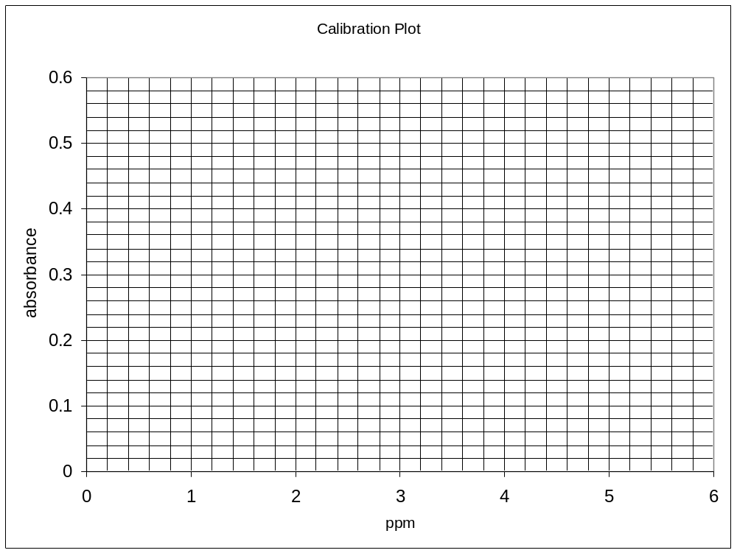

(b) Use the graph to determine the concentration of samples X, Z, and M. 1

Sample X .......................... Sample Z .................................... Sample M ..............................

(c) Which of the results had the least validity? Explain your answer. 1

........................................................................................................................................................

........................................................................................................................................................

........................................................................................................................................................
Student Number …………………………

MARKS
Question 27 (6 marks)

Discuss the problems associated with the use of CFCs and evaluate the effectiveness of the use of the replacement chemicals to CFCs. 6

.................................................................................................................................................................

..................................................................................................................................................................

..................................................................................................................................................................

..................................................................................................................................................................

..................................................................................................................................................................

..................................................................................................................................................................

..................................................................................................................................................................

..................................................................................................................................................................

..................................................................................................................................................................

..................................................................................................................................................................

..................................................................................................................................................................

..................................................................................................................................................................

..................................................................................................................................................................

..................................................................................................................................................................

...................................................................................................................................................................

..................................................................................................................................................................

..................................................................................................................................................................

..................................................................................................................................................................

..................................................................................................................................................................

Question 28 (7 marks)

The diagram shows an outback region, Unnice valley, located just at the foot of a limestone mountain.
The region centres around a meandering river that goes out to sea at D. Water analysis was done at
points A, B, C and D as part of an environmental assesment of the feasibility of erecting a housing
development for the workers in the already existing industries in the area. Since the town is rather
remote, no town water supply is yet available. It is proposed that the residents obtain their
drinking water from bores, rainfall tanks and from the river. It is also envisaged that the river
would provide food (fish) and recreational facilities for the residents.

wind blowing from the north
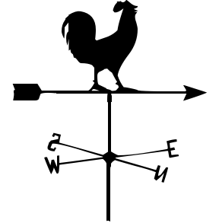
chicken farm
nuclear reactor
metal smelter
sea water
Unnice Valley
proposed housing development
A
B
C
D
to Limestone mountain
vegetable farm
N
S

E
W

Shown below is the experimental results of analysis of water samples at A,B,C and D

Substance/Area | A | B | C | D
Dissolved Oxygen (mg L⁻¹) | 8.0 | 8.0 | 3.0 | 2.0
Temperature (⁰ C) | 15 | 17 | 18 | 20
pH | 3.0 | 4.0 | 7.5 | 7.0
Cl⁻ (mol L⁻¹) | 10⁻⁴ | 10⁻⁴ | 10⁻³ | 0.3
Ca ²⁺ (mg L⁻¹) | 10 | 10 | 200 | 250
BOD | 3 | 3 | 200 | 300

Question 28 continues next page
Student Number …………………………

Question 28 continued..
MARKS

(a) What is the possible cause of the observed river water pH in area A and B? Justify your
answer with an equation. 2

..................................................................................................................................................

...................................................................................................................................................

..................................................................................................................................................

(b) Explain the effect of high calcium ion concentration in the water obtained in area C if this
water is used for household purposes. 2

...................................................................................................................................................

...................................................................................................................................................

....................................................................................................................................................

(c) Assess the capacity of the river system to provide food and recreational facilities
(such as boating or swimming) for the residents of this proposed housing development. 3

.....................................................................................................................................................

......................................................................................................................................................

.......................................................................................................................................................

.......................................................................................................................................................

.......................................................................................................................................................

.......................................................................................................................................................

Section II

25 marks

Attempt question 29
Allow about 45 minutes for this section

Answer the question in a writing booklet. Extra writing booklets are available.
Show all relevant working in questions involving calculations.

Question 29 MARKS

(a) During your practical work you performed a first hand investigation to observe the reaction
of sulfuric acid acting as an oxidizing agent.

(i) Identify a risk associated with this procedure. 1

(ii) Outline the procedure used and the results you obtained. 2

(b) Sulfur dioxide is converted to sulfur trioxide by the contact process.
Consider the following information.

2 SO₂ (g) + O₂ (g) 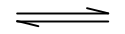 2 SO₃ (g) ΔH = – 198 kJmol⁻¹

 | Reactant Concentrations (mol L⁻¹) |  | Product Concentrations (mol L⁻¹)
550 ºC | SO₂ | O₂ | SO₃
Initial | 1.13 | 1.78 | 0
Final | 0.950 | x | 0.180

(i) Write the equilibrium constant expression for this reaction. 1

(ii) Determine the value of x and hence calculate the equilibrium constant. 3

(iii) Does the reaction favour the reactants or the products at 550 ºC?
Explain your answer. 1

(iv) Why is a temperature range of 500–600 ºC used in the contact process? 2

Question 29 continues next page
MARKS
Question 29 continued..

(c) Sodium hydroxide is manufactured from sodium chloride by electrolysis.

Describe the advantages and disadvantages associated with using a mercury cell to
produce sodium hydroxide. 4

(d) Soaps and detergents act as emulsifying agents when removing stains from materials,
however, they have different structures.

(i) Explain how soaps OR detergents act as emulsifying agents. 4

(ii) Distinguish between soaps and detergents in terms of their effect in hard water. 2

(e) The Solvay process is a series of reactions in the production of sodium carbonate.

(i) Identify one use of sodium carbonate. 1

(ii) Write an overall equation for the production of sodium carbonate from
sodium chloride and calcium carbonate. 1

(iii) Calculate the mass and volume of carbon dioxide produced at 25 ºC and 100 kPa
when 1000 kg of calcium carbonate is heated.. 3

End of Test 

